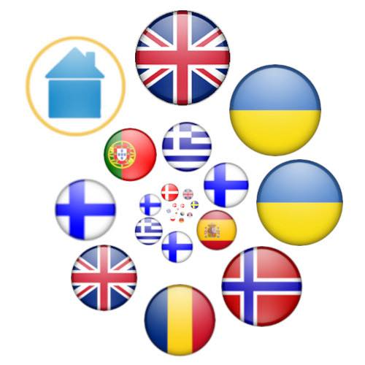

HOME COMPOSED SONG CONTEST 2026
APPLICATION FORM

Information about you
Your name:
Your country:
Your email:
Your favourite Eurovision song:
Your favourite HCSC song:

Biography
Tell us about you, how your song came to light & a greeting for the participants:

Information about the song
Song Title:
English translation of the song title (if applicable):
Performed by:
Music by:
Lyrics by:
Lyrics (leave blank if instrumental only):

Declaration of work
Please sign below as confirmation that the song being submitted is your own original work and that the song has not been generated for you by Artificial Intelligence or a cover version.
If in doubt, full contest rules can be found on the official 2026 HCSC website: https://home26.org/rules

Name: ______________________________

Signature: ______________________________

Date: ______________________________

In addition to the completion of this form by deadline 23:59 30th September 2026 (CET), please attach the following files to your email:

- 2 photos of the artist
- The song in mp3 or WAV format

Email your application to hcsc26@yahoo.com – we will reply to all applications within 24 hours, confirming receipt of your entries.

We wish you all the very best for this year’s contest
May the best song win!

